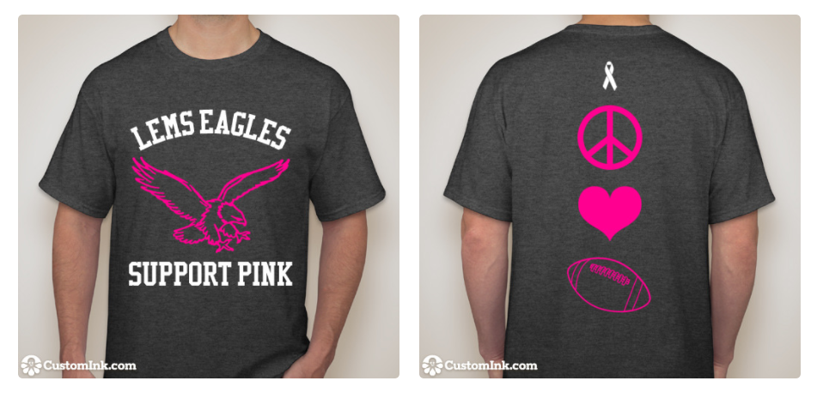
**All proceeds will go toward a charity or family impacted by cancer in our community**

Please fill out your order information below:

First and Last Name __________________________________________
Students only: Grade ______ 1st period teacher _____________________________
Size of shirt(s) (adult sizes only) __________

Total price _____________

Form of payment _________________ (cash/check/online payment)
*Please make all check payments out to Lake Elkhorn Middle School
*To pay online…
1. Log onto the LEMS website……..www.lems.hcpss.org
2. Select the “Online school purchases for students” (OSP) - this will take you to the OSP website.
3. Select CANCER T-SHIRT - this will take you to the payment form for the t-shirt.

